1.1 Logical Scheme
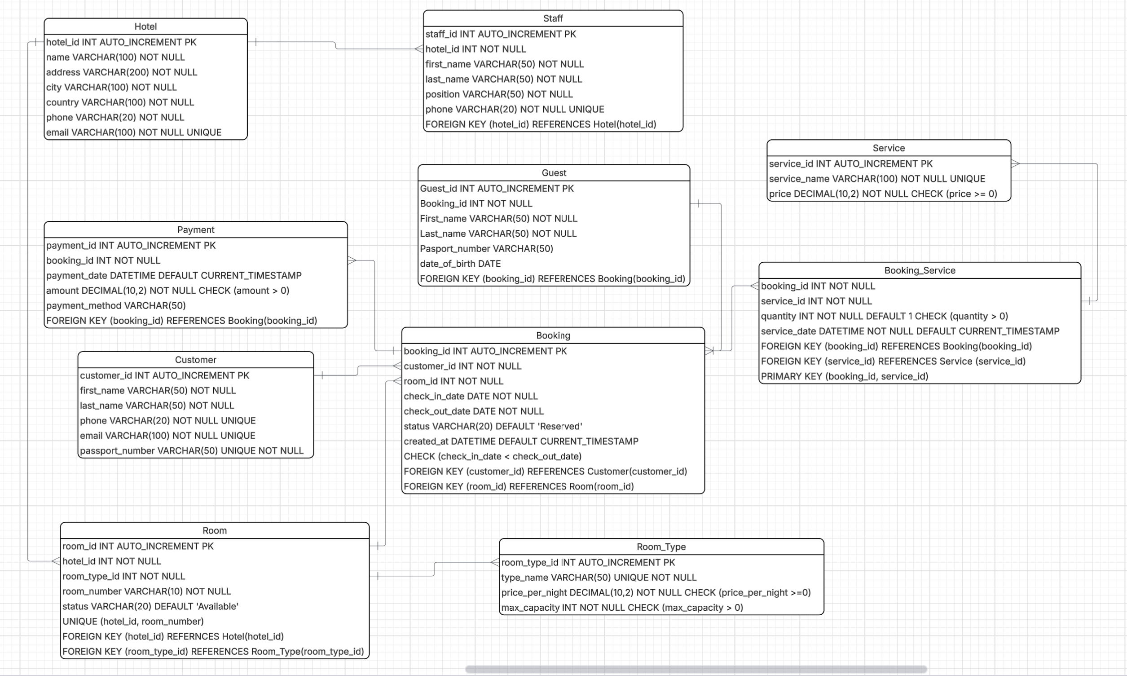

Objects

1) HOTEL: Table Description
Stores information about hotels.
Table Name | Field name | Field Description | Data Type / Constraints
Hotels | Hotel_id | Unique identifier of the hotel | Int, PK, AUTO_INCREMENT
 | name | Name of the hotel | VARCHAR(100), NOT NULL
 | address | Address of the hotel | VARCHAR(200), NOT NULL
 | city | City where the hotel is located | VARCHAR(100), NOT NULL
 | county | County where the hotel is located | VARCHAR(100), NOT NULL
 | phone | Contact phone number | VARCHAR(20), NOT NULL
 | email | Contact email address | VARCHAR(100) UNIQUE

The Hotel table represents the main entity that stores information about hotels. One hotel can have multiple rooms and multiple staff members. The hotel_id field is referenced by the Room and Staff tables.

Example with data

Hotel_id | Name | Address | City | County | Phone | Email
1 | Renaissance by Crystall | Kanish Satpaev 15B | Atyrau | Kazakhstan | 234 788 45 89 | crystall@apec.edu.kz
2 | River Palace | Aiteke Bi 55 | Atyrau | Kazakhstan | 877 234 34 25 | river@apec.edu.kz

2) STAFF: Table Description
Stores information about employees.

Table Name | Field name | Field Description | Data Type / Constraints
Staff | Staff_id | Unique identifier of the staff member | Int, PK, AUTO_INCREMENT
 | Hotel_id | Hotels where the staff members work | INT, FK
 | First_name | Staff first name | VARCHAR(50) NOT NULL
 | Last_name | Staff last name | VARCHAR(50) NOT NULL
 | Position | Job position | VARCHAR(50) NOT NULL
 | Phone | Staff phone number | VARCHAR(20) UNIQUE

The staff table stores information about employees working in a hotel. Each staff member belongs to one hotel through the hotel_id foreign key. One hotel can employ many staff members.

Example with data

Staff_id | Hotel_id | First_name | Last_name | Position | Phone
1 | 1 | Aruzhan | Tulegenova | HR Manager | 8778 678 23 45
2 | 1 | Moldir | Olzhabaeva | Manager | 8775 345 67 89
3) ROOM TYPE:
Stores information about room categories.

Table Name | Field name | Field Description | Data Type / Constraints
Room_type | Room_type_id | Unique identifier of the room type | Int, PK, AUTO_INCREMENT
 | Type_name | Type of the room | VARCHAR(50), NOT NULL
 | Price_per_night | Cost per night | DECIMAL(10,2) NOT NULL
 | Max_capacity | Maximum number of guest | INT, NOT NULL

The room_type table defines the categories of rooms offered by the hotel. It stores pricing and capacity information for each type. One room type can be assigned to many rooms.

Example with data

Room_type_id | Type_name | Price_per_night | Max_capacity
1 | Single | 50 | 1

4) ROOM: Table Description
Stores information about hotel rooms

Table Name | Field name | Field Description | Data Type / Constraints
Room | Room_id | Unique identifier of the room | Int, PK, AUTO_INCREMENT
 | Hotel_id | Hotel where the room is located | INT, FK
 | Room_type_id | Type of the room | INT, FK
 | Room_number | Room number | VARCHAR(10) NOT NULL
 | Status | Room availability status | VARCHAR(20) NOT NULL

The room table stores information about all rooms available in a hotel. Each room belongs to a specific hotel and has a defined room type.

Example with data

Room_id | Hotel_id | Room_type_id | Room_number | Status
1 | 1 | 2 | 127 | Available

5) CUSTOMER: Table Description
Stores information about customers

Table Name | Field name | Field Description | Data Type / Constraints
Customer | Customer_id | Unique identifier of the customer | Int, PK/FK
 | First_name | Customer first name | VARCHAR(50) NOT NULL
 | Last_name | Customer last name | VARCHAR(50) NOT NULL
 | Phone | Customer phone number | VARCHAR(20) UNIQUE
 | Email | Customer email | VARCHAR(100) UNIQUE

The Customer table stores personal information about users who make reservations. Each customer can create multiple bookings. The customer_id field is referenced in the Booking table.

Example with data

Customer_id | First_name | Last_name | Phone | Email
1 | Asylai | Zhumakulova | 8775 456 23 67 | asylaiiiii@gmail.com

6) BOOKING: Table Description
Stores booking information

Table Name | Field name | Field Description | Data Type / Constraints
Booking | Booking_id | Unique identifier of the booking | Int, PK/FK, AUTO_INCREMENT
 | Customer_id | Customer who made the booking | INT, FK
 | Room_id | Booked room | INT, FK
 | Check_in_date | Check-in date | DATE, NOT NULL
 | Check_out_date | Check-out date | DATE, NOT NULL
 | Booking_status | Status of the booking | VARCHAR(20), NOT NULL

The Booking table stores information about room reservations. Each booking is linked to one customer and one room. A customer can have multiple bookings, and a room can appear in different bookings over time.

Example with data

Booking_id | Customer_id | Room_id | Check-in Date | Check-out | Booking_status
1 | 2 | 3 | 2024.05.05 | 2024.07.05 | Confirmed
2 | 3 | 2 | 2024.01.05 | 2024.03.05 | Completed

7) SERVICE: Table Description
Stores information about additional hotel services.

Table Name | Field name | Field Description | Data Type / Constraints
Service | Service_id | Unique identifier of the srevice | Int, PK AUTO_INCREMENT
 | Service_name | Name of the service | VARCHAR(100), NOT NULL
 | Price | Service price | DDECIMAL(10,2), NOT NULL
 | Description | Description of the service | TEXT

The Service table stores a list of additional services provided by the hotel. These services can be ordered during a booking. The table is connected to bookings through the booking_service table.

Example with data

Sevice_id | Service_name | price | description
1 | Room cleaning | 15 | Daily cleaning service

8) BOOKING_SERVICE: Table Description
Junction table connecting bookings and services.

Table Name | Field name | Field Description | Data Type / Constraints
Booking_service | Booking_id | Booking identifier | Int, PK, FK
 | Service_id | Service identifier | INT,PK, FK
 | Quantity | Number of services ordered | INT,NOT NULL
 | Service_date | Date when the service was provided | DATE

The Booking_Service table is a junction table that connects bookings and services. It creates a many-to-many relationship between Booking and Service. One booking can include multiple services, and one service can be used in multiple bookings.

Example with data

Bookin_id | Service_id | Quantity | Service_date
1 | 1 | 2 | 12.12.2012

9) PAYMENT: Table Description
Stores payment information.

Table Name | Field name | Field Description | Data Type / Constraints
Payment | Payment_id | Unique identifier of the payment | Int, PK, AUTO_INCREMENT
 | Booking_id | Booking related to payment | INT, FK
 | Amount | Payment amount | DECIMAL(10,2), NOT NULL
 | Payment_date | Date of payment | DATE, NOT NULL
 | Payment_method | Method of payment | VARCHAR(50), NOT NULL

The Payment table stores information about payments made for bookings. Each payment is linked to a booking through the booking_id foreign key. One booking may have one or more payments depending on the payment process.

Example with data

Payment_id | Booking_id | Amount | Payment_date | Payment_method
1 | 1 | 235 | 13.04.2026 | Cash

10) GUEST: Table Description
Stores guests staying in a booking

Table Name | Field name | Field Description | Data Type / Constraints
Guest | Guest_id | Unique identifier of the guest | Int, PK, AUTO_INCREMENT
 | Booking_id | Booking to which the belongs | INT, FK
 | First_name | Guest first name | VARCHAR(50), NOT NULL
 | Last_name | Guest last name | VARCHAR(50), NOT NULL
 | Passport_number | Guest passport number | VARCHAR(50)
 | Date_of_birth | Guest date of birth | DATE

The Guest table stores information about individuals staying in the hotel. Each guest is linked to a booking using the booking_id foreign key. One booking can include multiple guests.

Example with data

Guest_id | Booking_id | First_name | Last_name | Passport | Date_birth
1 | 1 | Chase | Miller | AB2347 | 09.05.1996

